FOR IMMEDIATE RELEASE

BREC upgrades with Lotterywest grant

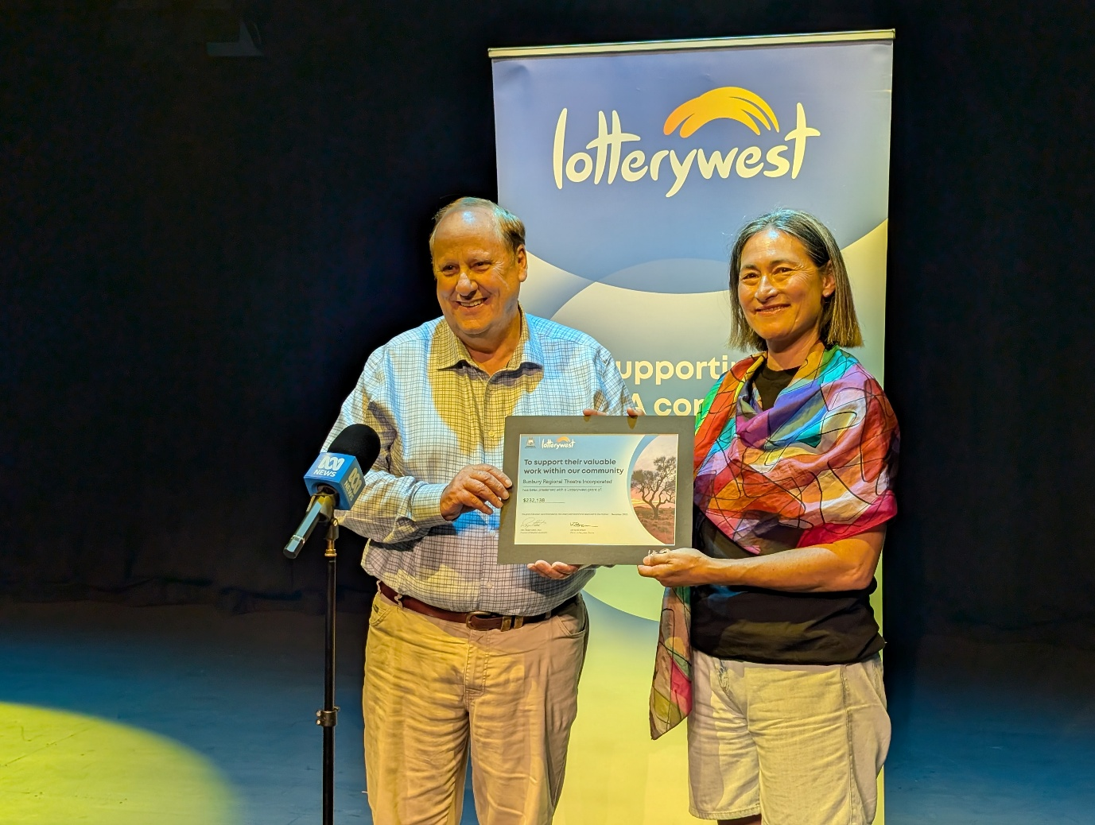
IMAGE CREDIT: SUPPLIED | Member for Bunbury Don Punch presents the Lotterywest grant certificate to BREC Board Chair Amanda Yip
20 February 2026 – BREC | The Bunbury Regional Entertainment Centre (BREC) is futureproofing its lighting and communications equipment thanks to a Lotterywest grant worth more than $230,000.
The funding will continue much needed equipment upgrades at the South West’s leading performing arts centre.
Top of the list is the replacement of aging stage lighting in BREC’s main theatre, Stage One. 36 older lights will be replaced by 16 LED units. The new lights will provide a multitude of options for touring companies and locally made shows such SWOC’s 2025 production of Carmen and will be quicker and easier to program.
The new LED lights will also save BREC up to $7000 a year in electricity. A further $5330 per year will be saved in labour costs, as required maintenance hours on the lights fall from 90 hours a year to just eight.
The old lights will be moved into the Cube Theatre, adding redundancy to the existing lighting rig - extending its life for another five years and allowing BREC to continue delivering quality productions to smaller audiences in this flexible venue.
Visitors to BREC who live with hearing difficulties have long struggled with the current hearing assistance system, which has been rendered obsolete by modern hearing aids. Those days are over, as part of the Lotterywest grant will allow BREC to install a new, state of the art, assisted hearing loop system.
It will allow up to 400 patrons to connect their own devices at once. It can also be utilised for live audio description for vision-impaired guests. This will be an entirely new program for BREC, which will eventually be supported by volunteer describers at selected shows and events.
Finally, BREC and the City of Bunbury recently made a capital investment of $71,000 in a new wireless communications system for the Stage One Theatre, providing technical staff and crew with reliable, low-latency communication during performances. This is critical to ensuring a seamless audience experience and a safe one backstage. Lotterywest’s Arts and Culture Infrastructure grant will allow BREC to extend this modern system to the Cube Theatre and Wellington Suite, supporting events like the BREC international Film Festival, and for the first time establishing a unified network linking all production staff and volunteers on a single, integrated platform.
BREC Executive Director Fiona de Garis said the upgrade was a major step forward for the Centre’s future.
“This grant means we can continue delivering professional, high-quality performances for our region, while also improving access and usability for both audiences, local and visiting artists,” she said.
“Upgrading to modern LED lighting will reduce power use and maintenance, and the new assisted hearing system will make a real difference for patrons who have previously struggled to engage fully in the theatre experience. We’re grateful to Lotterywest for backing infrastructure that strengthens the arts in regional WA.”
Member for Bunbury, Don Punch, said the grant will assist BREC to continue providing the best experience to South West audiences now and into the future.
“BREC has a well earned reputation for innovation that is reflected by this project and the
technology and infrastructure upgrades it will deliver,” he said.

“The Board, management and staff at BREC should be commended for their commitment to
continuous improvement and the pride they take in their standing as an exceptional
performing arts venue.”

For further information, interviews or images please contact:

Eddie Scown, Communications Coordinator
+61 8 9792 3112 | eddie@bunburyentertainment.com

Sarah Whitby, Senior Marketing Coordinator
+61 8 9792 3115 | sarah@bunburyentertainment.com

ENDS

