FOR IMMEDIATE RELEASE

FEATHERS WILL FLY AS BALLET AND CIRCUS COLLIDE AT BREC

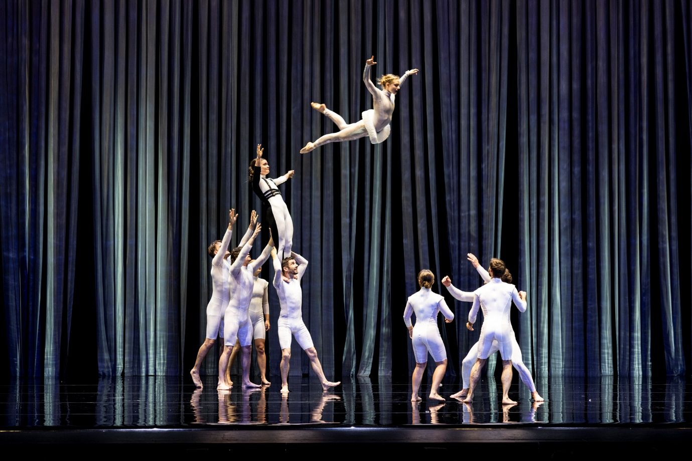
Image Credit: Pia Johnson
5 February 2026 – BREC | The world's most romantic ballet is re-imagined with circus flair, as Circa brings Duck Pond to the Bunbury Regional Entertainment Centre.
Full of Circa’s signature physicality and shot through with cheeky humour and a thoroughly contemporary energy, Duck Pond transforms the legendary stories of Swan Lake and The Ugly Duckling as a circus spectacular.
Be swept away by this tale of swans and hapless princes sparkling with quirky touches like the sequinned flipper-wearing duck army and a burlesque black swan. There are sumptuous aerials, jaw-dropping acrobatics and of course feathers! Touching, funny and utterly entertaining, Duck Pond is a tale of identity and finding your true self.
Circa is at the forefront of the new wave of contemporary Australian circus – pioneering how extreme physicality can create powerful and moving performances. It continues to push the boundaries of the art form, blurring lines between movement, dance, theatre and circus.
Under the direction of circus visionary Yaron Lifschitz, Duck Pond features an ensemble of exceptional, multi-skilled circus artists. Leading the way with a diverse range of thrilling creations, their works have been greeted with standing ovations, rave reviews and sold-out houses across six continents.
Circus fans will get a kick out of the high-flying performances, and wild on-stage antics. But Composer Jethro Woodward said fans of Swan Lake will find this re-imagined performance stays faithful to the original Tchaikovsky ballet.
“The original music from Tchaikovsky is woven into every moment of the score of Duck Pond,” Woodward said.
“I began by sampling various recordings of the Tchaikovsky score from records and CDs. Taking the sections that I felt most connected to, and relevant to the work, or moments that are simply iconic.”
“These sampled swan lake breakbeats have then been played and woven into the new material alongside other contemporary instrumentation including drums, drum machines, electric guitar, synths & pianos.”
BREC Executive Director Fiona de Garis said Circa’s past performances at BREC have been uplifting for local audiences.
"Circa last performed at BREC just one week after the first tornado hit Bunbury in 2024. We invited affected residents from Withers and surrounding suburbs to come along for free and have a break from the clean up and distress.”
“Circa’s work is so joyful and always demonstrates the power of humans working together and trusting each other – a wonderful offer to audiences who come away from their shows uplifted and energised. We are so pleased to able to offer that experience again for our community. “
EVENT DETAILS

WHAT: BREC presents DUCK POND by Circa
Created by Yaron Lifschitz and the Circa Ensemble
WHERE: Bunbury Regional Entertainment Centre
WHEN: TUESDAY March 31 | 6:30pm
Foyer and bars open from 5:30pm
FOR AGES: All ages

BOOKINGS AND INFO https://www.bunburyentertainment.com/whats-on/duck-pond-by-circa/ or call the BREC Box office on 1300 661 272

IMAGES ARE AVAILABLE TO DOWNLOAD HERE
Please use image credits as specified in image title

We gratefully acknowledge the sponsors and supporters of this show:

Duck Pond is co-commissioned by QPAC and The Arts Center at NYU Abu Dhabi, The Art House Wyong, Frankston Arts Centre, HOTA – Home of the Arts, Merrigong Theatre Company and Orange Civic Theatre.
Circa acknowledges the assistance of the Australian Government through Creative Australia, its principal arts investment and advisory body and the Queensland Government through Arts Queensland.
Circa is based in Meanjin (Brisbane) on the lands of the Jagera and Turrbal people. We respectfully acknowledge the Traditional Custodians of the many lands on which we create and perform. We pay our respects to Elders past, present and emerging.
Always was. Always will be.

Duck Pond is created by Yaron Lifschitz and the Circa ensemble.
Director, Stage Design Yaron Lifschitz
Composer and Sound Designer Jethro Woodward
Costume Designer Libby McDonnell
Lighting Designer Alexander Berlage
Associate Director Marty Evans
Dramaturg/Associate Choreographer Rani Luther
Voice Over Artist Elise Greig

For further information, interviews or images please contact:

Eddie Scown, Communications Coordinator
+61 8 9792 3112 | eddie@bunburyentertainment.com

Sarah Whitby, Senior Marketing Coordinator
+61 8 9792 3115 | sarah@bunburyentertainment.com
ENDS

