EMBARGOED UNTIL TUESDAY FEBRUARY 24 2026

Real Bunbury stories brought to life in BREC original production

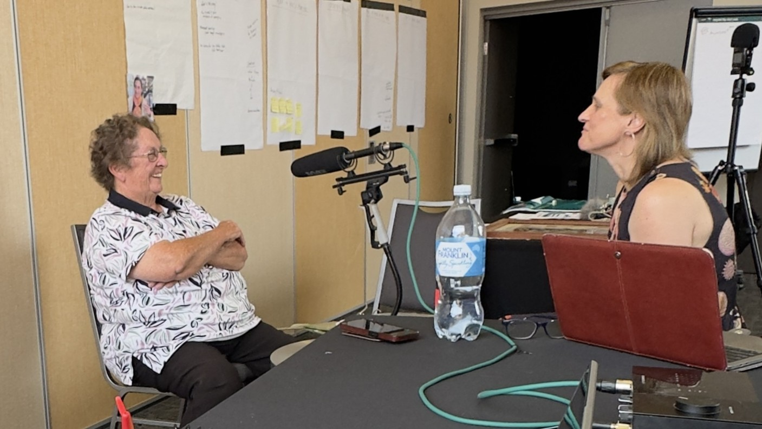
Former Pat’s Snack Bar owner Doreen Roney shares her stories with This Is Where creator Siobhan Maiden. | Image Supplied
February 24 – BREC | In April, Bunbury Regional Entertainment Centre (BREC) invites you to look at your city from another perspective.
This is where… is a guided walking theatre experience. Audiences will be taken on a walk through the Bunbury CBD to see live theatre based on true stories, performed in the places they actually happened.
The BREC original production is the culmination of six years of research and development, starting at the inaugural BREC Artists Retreat held at Donnelly River Village in 2019. Creator Siobhan Maiden has collected a diverse range of true stories from Bunbury locals, and with her experience as a documentary filmmaker, radio presenter, and drama teacher, written them for live performance by actors.
“I really enjoy fiction, but there are so many incredible true stories that there is hardly a need to invent characters or scenarios.” Maiden said.
“I love honouring moments, people and places who often don’t expect it or think they deserve it. Finding beauty and value in the everyday, the ordinary and familiar enhances our quality of life, as we appreciate the here and now rather than seeing the grass always being greener elsewhere.”
Rather than recreating these stories on stage, actors will perform them in the actual locations they happened. Audiences will be guided on a walking tour of the Bunbury CBD, and they will stop at various locations to watch a scene based on real life stories.
More than 100 locals shared their firsthand stories with Maiden in the development of This is where... Of those, 30 were chosen and refined into 10 scenes located across the CBD. They explore Bunbury’s nightlife, car scene, current and former local businesses, and the people who made it all happen.
A theme which runs through all 30 stories selected is that they all reflect a small act of rebellion. Maiden didn’t seek this out as a qualifier, but it emerged during the process of curating them that there was a clear demonstration of courage displayed in each.
“I have deep respect for each person whose story appears in this work. They have taken risks, endured challenges, and may never know the ripple effects of their actions,” Maiden said.
“This is where… is a tribute to hidden courage. To ordinary places where something quietly brave once happened. The real answer to the title’s unfinished sentence is probably: This is where I showed courage.”
Your journey will start with your group in The Cube Theatre. A series of short scenes bring Bunbury’s past and present to life - blending local stories and glimpses of the city you thought you knew.

Then the show spills into the city, where across seven locations in the Bunbury CBD, you’ll encounter ordinary places that hold extraordinary layers of meaning - spaces where private moments linger, shaping who we are and how we belong.

BREC Executive Director Fiona de Garis said developing a brand-new production is a significant undertaking.
“It requires creative vision, technical skill and a great deal of collaboration. With This is where…, it has been a genuine delight to partner with organisations and businesses that share the CBD with us. Their generosity has allowed these stories to unfold in the very places they happened. Add in some talented local performers, and the stage is set for a truly special experience.
“It is a privilege to help bring local stories to life with care and respect, and I am very much looking forward to audiences sharing this experience and seeing Bunbury from a fresh perspective.”
If you want to be a part of bringing these stories back to life, BREC is on the lookout for volunteer audience guides. They’ll help keep This is where… safe, on time, and connected to the flow of the experience.
This is where… will be performed daily from April 13 – 18. Walking shoes will be essential as audiences are guided on a walking theatre experience through the Bunbury CBD. Tickets, session times, and volunteer expressions of interest are available online or through the BREC box office.

Synopsis
This is where…
Walk the streets you know, hear the stories you don’t.
A guided walking theatre experience.

For one week only, BREC presents This is where… an original theatre production by Bunbury artist Siobhan Maiden, crafted from stories shared by locals, for locals.

Step into the streets and connect with Bunbury in a way you never imagined. See your city from another perspective. Hear untold tales. Be surprised by unexpected points of view. Real Bunbury moments, performed in the places they happened.

This is a rare chance to see Bunbury differently - and feel more connected to the place you call home.

Your journey begins at BREC inside The Cube.

A series of short scenes bring Bunbury’s past and present to life - blending local stories and glimpses of the city you thought you knew.

Then the show spills out into the city.

The audience divides into small, guided groups and heads out on foot. Across seven locations in the Bunbury CBD, you’ll encounter ordinary places that hold extraordinary layers of meaning - spaces where private moments linger, shaping who we are and how we belong.

Before or after your experience, we invite you to visit our homage to Pat’s Snack Bar right outside BREC’s front doors, where burgers and crumpets are available for purchase.

This is a guided walking theatre experience (approximately 1.7km) and is best suited to patrons who are comfortable walking.
PERFORMANCE DETAILS

WHAT: BREC presents THIS IS WHERE…
WHERE: Bunbury Regional Entertainment Centre
The Cube Theatre, and the streets of Bunbury as a guided walking theatre experience
WHEN: MONDAY 13 APRIL – SATURDAY 18 APRIL
Foyers and bars open (1-hour prior to performance)
POST-SHOW: Pat’s Snack Bar open each day from 4:15pm – 10pm
FOR AGES: 14+ years
PATRON ADVICE: As a walking performance across multiple CBD locations, accessibility is limited. If you have access needs or questions about mobility, please contact BREC before booking so we can help you decide whether this experience is right for you.

BOOKINGS AND INFOhttps://www.bunburyentertainment.com/whats-on/this-is-where/ or call the BREC Box office on 1300 661 272

IMAGES ARE AVAILABLE TO DOWNLOAD HERE: LINK
Please use image credits in image titles.
This project was made possible by the Australian Government Regional Arts Fund, which supports the arts in regional and remote Australia.
Proudly supported by the WA Government.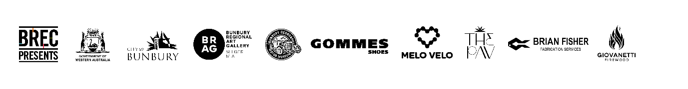

For further information, interviews or images please contact:

Eddie Scown, Communications Coordinator
+61 8 9792 3112 | eddie@bunburyentertainment.com

Sarah Whitby, Senior Marketing Coordinator
+61 8 9792 3115 | sarah@bunburyentertainment.com

ENDS

