FOR IMMEDIATE RELEASE

BREC GETS MAJOR BOOST IN FEDERAL ARTS FUNDING TARGETING REGIONS

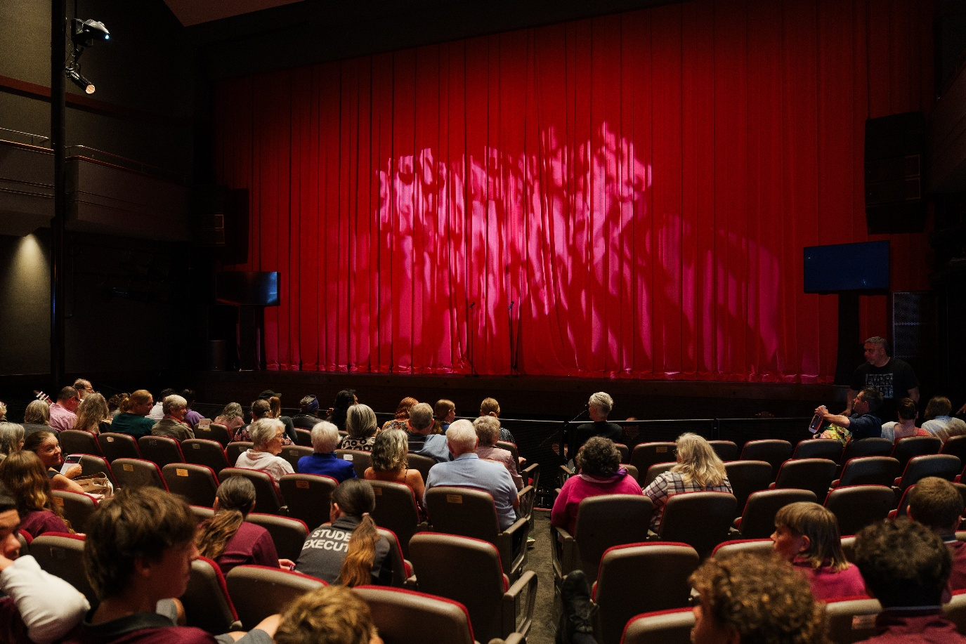
BREC is part of two groups which have received funding to boost audience engagement in the regions.IMAGE CREDIT | Ben Yew
28 JANUARY 2026 –
Bunbury Regional Entertainment Centre (BREC) is proud to announce it is the only venue nationally to be included in two of the three consortiums funded through Creative Australia’s Playing Australia Audience Development Multi-Year Investment Program 2026-2028.

This federally funded investment focuses on audience development for national tours in regional and remote communities. The program supports collaborative approaches by regional venues to grow audiences, deepen engagement with touring acts, and make interstate touring more financially viable - helping to ensure regional audiences have access to high-quality performing arts experiences comparable to those available in metropolitan centres.

Over the next three years, BREC will participate in both Audience Centred Touring (ACT) - a national venue-driven consortium delivering more performances to more people - and a consortium focused on growing audiences for First Nations performing arts in regional Western Australia, led by CircuitWest.

The third consortium funded nationally is focused on audience development in regional Tasmania.

ACT is a national consortium of six regional presenters across NSW, QLD and WA, re-imagining how touring connects with audiences.

Led by The Art House Wyong, the consortium also includes Orange Civic Centre, The Events Centre Caloundra, Pilbeam Theatre Rockhampton, Albany Entertainment Centre, and BREC.

Through structural reform and tailored, venue-based audience development plans, the consortium aims to shift touring from a product-centred model to one that is audience-centred. Touring works will be selected not only for artistic merit, but for their capacity to meaningfully engage local communities, reducing financial risk and increasing relevance for regional audiences.

BREC Executive Director Fiona de Garis said the shift is critical for regional venues.

“For Western Australian audiences, access to interstate productions is vital - but distance, freight costs and financial risk often limit what is possible. The ACT consortium creates a stronger touring model that ensures works genuinely connect with regional communities.”

“Being selected for two national consortiums in a highly competitive round was unexpected and deeply affirming. The First Nations Audience Development consortium builds perfectly on our existing work with Alcoa, including support for the appointment of BREC’s inaugural Elder in Residence, Dr Lynette Narkle. Together, these initiatives allow us to do careful, long-term audience development work that delivers real impact.”

The First Nations Audience Development consortium builds on BREC’s ongoing commitment to First Nations programming and audience development.

Guided by dedicated First Nations Audience Development Leads and coordinated by CircuitWest, BREC will work collaboratively over three years alongside Arts Margaret River, Harvey Recreation and Cultural Centre, and Matt Dann Theatre in Port Hedland in the Pilbara.

The consortium will build on CircuitWest’s First Nations Toolkit for presenters, strengthen local capability, and develop a best-practice framework to support inclusive audience growth across the sector.

CircuitWest Executive Director Philippa Maughan said the investment reflects a strong commitment to First Nations artists and regional audiences.

“This multi-year support enables a long-term, community-led approach to growing audiences for First Nations performing arts in regional WA.”

“By investing in relationships and local capability, this program supports First Nations artists to share their stories, while ensuring regional communities have greater access to bold, diverse and high-quality First Nations work.”

Dr Narkle said, “With so many outstanding young Noongars ready to step up and lead, we must leave room for the next generation to share our stories - traditional and contemporary - and develop new strategies that will make a real difference.”

More information

PAC Australia: https://paca.org.au/playing-australia-audience-development-fund-recipients/

Creative Australia: https://creative.gov.au/news-events/news/creative-australia-touring-programs-bring-more-live-performing-arts-audiences

For interviews, additional comment or images please contact:

Eddie Scown | Communications Coordinator
+61 8 9792 3112 | eddie@bunburyentertainment.com

Sarah Whitby | Senior Marketing Coordinator
+61 8 9792 3115 | sarah@bunburyentertainment.com

ENDS

